Course Project: Software System Design De Andre King

SWENG 837 8/7/2024

Selected System:

**Qalb+**: A platform facilitating the search for nearby healthcare providers and doctors, considering specialties and accepted insurance types.   
  
**Business Requirements:**Overall, the main purpose of theQalb+ system is to address the challenge faced by patients in efficiently finding suitable healthcare providers based on their location, specialty, and insurance coverage. The approach we are looking at, is to develop a system that is not completely user-resource dependent and is lightweight enough to be operated off mobile devices. This system will allow for top rated, real-time search results, file sharing, messaging, and high quality responses from customer service.  
  
**Functions:**• Search:  
 o Filtering capability allowing users to refine search results based on location, specialty, and insurance coverage.  
 o Provides the most relevant search results as top results.  
 o Auto-suggest results based on search criteria.   
 o Highlights results based on close proximity to search criteria. • Appointment Scheduling:  
 o Allows for booking appointments directly with service providers within the platform.  
 o Records and stores customer information and booking history.   
 o Allows for integration with existing calendars.  
 o Allows to schedule and automate reminders.   
  
• Profile Management:  
 o Allows for configuration of contact information and profile settings.  
 o Manage single-sign-on permissions.  
 o Configure profile preferences.  
 o Integration with speech-to-text functionality for meeting transcription.  
  
• Speech Communication:  
 o Real-time voice communication between team members.  
 o Voice recording and playback for meetings.  
 o Screen sharing.  
 o Integration with speech-to-text functionality for meeting transcription.

### • Device Compatibility: o Support for input devices like wireless pen tablets and touch screens. o Output to display stations and smartphones. o Optimized user interfaces for different screen sizes and orientations. o Compatibility with various operating systems (Windows, macOS, iOS, Android). **Target Users & Their Needs**

| **Type** | **Actor** | **Goal Description** |
| --- | --- | --- |
| **Primary** | Healthcare Providers / Doctors | These are the healthcare professionals that would be listed on the platform. Patients/Users would directly interact with the Qalb+ system and request these professionals based on specialties and accepted insurance types. |
|  | Patients/Users | These are the people that are intending to use the services of the platform. Patients/Users would directly interact with the Qalb+ system and request these professionals based on specialties and accepted insurance types. |
|  | Platform Developers | These are the professionals that developed and will maintain the platform to the expected requirements and industry standards. Security protocols, regulations, and reliable UI/UX experience are expected. |
| **Supporting** |  |  |
|  | Insurance Companies | Being that the platform’s search criteria includes the different types of insurances, its integration with insurance companies is important as well. It will allow users/patients to see what medical professionals are in-network with their plan. |
|  | Single Sign On Systems | Being that the platform’s search criteria includes the different types of insurances & specialties, its integration with other popular platforms can be helpful for access to other types of personal data and efficient retrieval of patient data/preferences |
| **Offstage** |  |  |
|  | Government Agencies/ Local Area Laws/HIPAA | These entities are important because they govern the regulations and standards around patient data and its security. |
|  | SEO Factors | This factor is important because it will influence the search results based off of third party ratings or reviews |
|  | Advertisement Systems | Depending on the most optimal search results, advertisements could be generated on the platform to assist with driving business to these healthcare providers |

**Sample Business Goals:**

1.1 Searching for a new primary care physician

1.2 Searching for a specialist  
 1.3 Managing your healthcare account on the platform  
 1.4 Utilizing the platform for an emergency care situation  
 1.5 Utilizing the customer support feature on the platform

### **Use Cases** 1. Searching for a new primary care physician

| Use Case Section | Comment |
| --- | --- |
| Use Case Name | Searching for a new primary care physician |
| Scope | Qalb+ platform |
| Level | user-goal |
| Primary Actor | Patient/User |
| Stakeholders and Interests | Patient/User: Wants easy to find, well-reviewed primary care physicians. Wants to be able to filter by speciality and if their insurance is accepted.  Healthcare Provider: Wants to be well displayed in search results and reach new clients. Wants to have the option to manage their profile and inquiries/scheduling that comes in.   Insurance Companies: Wants to attract and be advertised to users who are in-network. Should be able to access insights about user search results and its usage.   Platform Developers: Wants to maintain a secure and user-friendly platform. Ensures that it's compliant with the government agencies healthcare regulations. |
| Preconditions | Patient/User is live and authenticated on the platform with its own preferences and profile established. |
| Success Guarantee | Patient/User finds & secures a new primary care physician. The healthcare provider has now secured a new client. |
| Main Success Scenario | 1. Patient/User lands on the Qalb+ platform home page. 2. Patient/User heads to the search bar and enters a search inquiry for a primary care physician within their neighborhood and within their insurance network. 3. The platform presents the 10 most relevant options based on the criteria given. 4. Patient/User selects the most optimal option and schedules an appointment with them through the platform portal. 5. The platform provides the patient/user with a confirmation of appointment scheduled and further instructions of what is needed for the appointment. 6. Patient/User has options to be directed back to Qalb+ landing page or the physician profile page. |
| Extensions | Alternative Flow: If a 501 or 404 error occurs, the platform should be able to display the 404 or 501 error and the patient/user can try again after refreshing the page. |
| Special Requirements | N/A |

## 2. Searching for a specialist

| Use Case Section | Comment |
| --- | --- |
| Use Case Name | Searching for a specialist. |
| Scope | Qalb+ platform |
| Level | user-goal |
| Primary Actor | Patient/User |
| Stakeholders and Interest | Patient/User: Wants easy to find, well-reviewed specialists. Wants to be able to filter by their insurance provider.  Specialist/Healthcare Provider: Wants to be well displayed in search results and reach new clients. Wants to have the option to manage their profile and inquiries/scheduling that comes in.   Insurance Companies: Wants to attract and be advertised to users who are in-network. Should be able to access insights about user search results and its usage.   Platform Developers: Wants to maintain a secure and user-friendly platform. Ensures that it's compliant with the government agencies healthcare regulations. |
| Preconditions | Patient/User is live and authenticated on the platform with its own preferences and profile established. |
| Success Guarantee | Patient/User finds & secures a new primary care physician. The healthcare provider has now secured a new client. |
| Main Success Scenario | 1. Patient/User lands on the Qalb+ platform home page. 2. Patient/User heads to the search bar and enters a search inquiry for an ear,nose, and throat doctor within their neighborhood and within their insurance network. 3. The platform presents the 10 most relevant options based on the criteria given. 4. Patient/User selects the most optimal option and schedules an appointment with them through the platform portal. 5. The platform provides the patient/user with a confirmation of appointment scheduled and further instructions of what is needed for the appointment. 6. Patient/User has options to be directed back to Qalb+ landing page or the physician profile page. |
| Extensions | N/A |
| Special Requirements | N/A |

## 

## 3. Managing your healthcare account on the platform

| Use Case Section | Comment |
| --- | --- |
| Use Case Name | Managing your healthcare account on the platform |
| Scope | Qalb+ platform |
| Level | subfunction |
| Primary Actor | Patient/Users |
| Stakeholders and Interests | Patient/User: Wants an easy to access, manageable profile page that will allow them to securely handle medical records, billing information, and scheduling.  Specialist/Healthcare Provider: Wants to have secure and confidential communication with patients. Wants to have patient/user records readily available.   Platform Developers: Wants to maintain a secure and user-friendly platform. Ensures that it's compliant with the government agencies healthcare regulations |
| Preconditions | Patient/User is live and authenticated on the platform with its own preferences and profile established. |
| Success Guarantee | Patient/User is able to securely adjust their medical records, billing information, and appointment scheduling on their profile within the platform |
| Main Success Scenario | 1. Patient/User clicks on the icon on the platform that allows them to head to their profile 2. The profile page should display areas to view uploaded medical records, an area designated to billing information, and an area dedicated to scheduled and past appointments. 3. Patient/User enters the medical records view and adds and downloads desired medical records 4. Patient/User updates their billing information to accommodate their new address 5. Patient/User reviews past appointments and notes left on them on in-house calendar 6. Patient/User makes adjusts like adding new information or canceling future scheduled appointments 7. Once Patient/User is satisfied with changes made on platform, they are able to save the changes and return to platform homepage |
| Extensions | N/A |
| Special Requirements | N/A |

4. Utilizing the platform for an emergency care situation

| Use Case Section | Comment |
| --- | --- |
| Use Case Name | Utilizing the platform for an emergency care situation |
| Scope | Qalb+ platform |
| Level | user-goal |
| Primary Actor | Patient/User |
| Stakeholders and Interests | Patient/User: They would like to receive quick and diligent medical care in the midst of an emergency. Having easy access to clear instructions and good communication with first responders/medical facilities is paramount.  HealthCare/Medical Professionals: Receiving the information efficiently in the midst of an emergency is important. Having clear and good communication with the patient aids in the best type of care being presented to them.  Platform Developers: Wants to maintain a secure and user-friendly platform. Ensures that it's compliant with the government agencies healthcare regulations |
| Preconditions | Patient/User is live and authenticated on the platform with its own preferences and profile established. |
| Success Guarantee | Patient/User is able to successfully reach emergency services, efficiently provide details on current issues, and recieve clear instructions on how to proceed in the midst of the emergency. |
| Main Success Scenario | 1. Patient/User navigates to the emergency page of the Qalb+ platform and proceeds to enter the information in the input field about the current emergency. 2. The Qalb+ platform should provide a questionnaire to help quickly triage the situation at hand 3. Based on the results of the questionnaire, the platform would present you with a few viable options on how to proceed with the situation at hand, including speaking to a live medical professional. 4. Patient/User opts to speak to a live medical professional. 5. Medical professionals should already have some of the information on hand from what was provided, so the triage process is a lot more efficient. 6. Once triage and diagnosis is complete, the Patient is connected with the most appropriate medical resources with clear instructions on how to proceed in this option. |
| Extensions | N/A |
| Special Requirements | N/A |

5. Utilizing the customer support feature on the platform

| Use Case Section | Comment |
| --- | --- |
| Use Case Name | Utilizing the customer support feature on the platform |
| Scope | Qalb+ platform |
| Level | user-goal |
| Primary Actor | Patient/User |
| Stakeholders and Interests | Patient/User: They would like to receive informative and responsive assistance. This includes being directed/connected with the proper resources.   Customer Support Representative: Wants to receive clear and descriptive requests in order to assist the patient/user with their issue.  Platform Developers: Wants to maintain a secure and user-friendly platform. Ensures that it's compliant with the government agencies healthcare regulations. |
| Preconditions | Patient/User is live and authenticated on the platform with its own preferences and profile established. |
| Success Guarantee | Patient/User is able to locate and access the customer support feature with minimal difficulty. No matter the severity, the Patient/User should be able to receive aid for their inquiry or challenge that they are having with the platform. |
| Main Success Scenario | 1. Patient/User clicks on the customer support help link on the platform 2. Patient/User encounters an autobot that inquires about the challenge they may be having with the platform. 3. The questionnaire must provide a robust amount of questions with many pathways depending on the type of answer 4. Recommendations to pages on the site map must be available and up-to-date options as well 5. Patient/User finishes the autobots questionnaire and finds resolve in the answer provided 6. Patient/User returns to the platform landing page |
| Extensions | N/A |
| Special Requirements | N/A |

## **Non-functional Requirements:**

## 

### **Performance**

## **Response Time:** The system should provide search results within a specified timeframe (e.g., under 3 seconds).

## **Scalability:** The platform must handle increasing numbers of users and data without compromising performance.

## **Load Testing:** Regular load testing should be conducted to identify and address performance bottlenecks.

### **Security**

## **Data Privacy:** Patient data must be securely stored and transmitted, complying with relevant regulations (e.g., HIPAA).

## **Authentication:** Strong authentication mechanisms should be implemented to protect user accounts. (Single Sign On)

## **Authorization:** Access controls must be in place to restrict data access to authorized personnel.

### **Usability**

## **User Interface:** The platform should have a user-friendly and intuitive interface.

## **Accessibility:** The system should be accessible to users with disabilities (e.g., screen readers, keyboard navigation).

## **Usability Testing:** Regular usability testing should be conducted to identify and address usability issues.

### **Reliability**

## **Availability:** The system should be available 24/7 with minimal downtime.

## **Fault Tolerance:** The platform should be able to recover from failures and continue operating.

## **Disaster Recovery:** A robust disaster recovery plan should be in place to protect data and restore services.

### **Maintainability**

## **Code Quality:** The codebase should be well-structured, documented, and easy to maintain.

## **Modularity:** The system should be designed with modular components for easy updates and enhancements.

## **Testability:** The system should be easily testable to ensure quality.

## 

## 

## 

## 

## 

## 

## 

## 

## 

## 

## 

## 

## 

## **System Design using Domain Modeling:** **1. UML Use Case Diagram**

**Searching for a new primary care physician**



**2. UML Domain Model**

| **Conceptual Class Category** | **Example from Qalb+ platform** |
| --- | --- |
| **Profiles** | Patient profile, Healthcare Providers, Profiles, System Administrator Profile |
| **Healthcare Services** | Healthcare Provider Information (from database), Insurance Information, Services, Review |
| **Other Systems (external)** | Single Sign On Options (Google, WebMD, ZocDoc) |
| **Transactions** | Billing Information, Insurance Coverage |
| **Transaction Line Items** | Copays |
| **Communication** | On-site Instant Messaging, Notifications, Emails |
| **Privacy** | HIPAA Compliance, Database Security |
| **Specialty** | Dermatology, Pediatrics |
| **Security** | Authentication, Encryption |
| **Help & Support** | FAQ |
| **Search** | Filters, Criterias, Results |
| **Insurance** | Plan Details, Out/In-Network |
| **Rating** | Reviews, Customer Feedback, Surveys |
| **Settings** | Account Preferences, Communication Options |
| **Location** | City, State, Zip Code, Facility, |
| **Directory** | List Of Providers |
| **Appointment** | Booking, Confirmations |
| **Assignments** | Post-Op Instructions, Appointment Checklists |
| **Data** | Usage Data, Appointment Statistics, Provider Data |
| **Telehealth** | Video Chat |

**2.** Prune EACH list of candidate conceptual classes according to the Domain Modeling.

| **Good Classes (Retained)** | **Bad Classes (Pruned)** |
| --- | --- |
| **Profiles** | **Telehealth** |
| **Data** | **Assignments** |
| **Search** | **Directory** |
| **HealthCare Services** | **Location** |
| **Appointment** | **Settings** |
| **Communication** | **Rating** |
| **Security** | **Transaction Line Item** |
| **Privacy** | **Help & Support** |
| **Insurance** | **Transaction** |
| **Other Systems (External)** | **Settings** |

Domain Model for the system by adding need-to-know associations and attributes.   
  
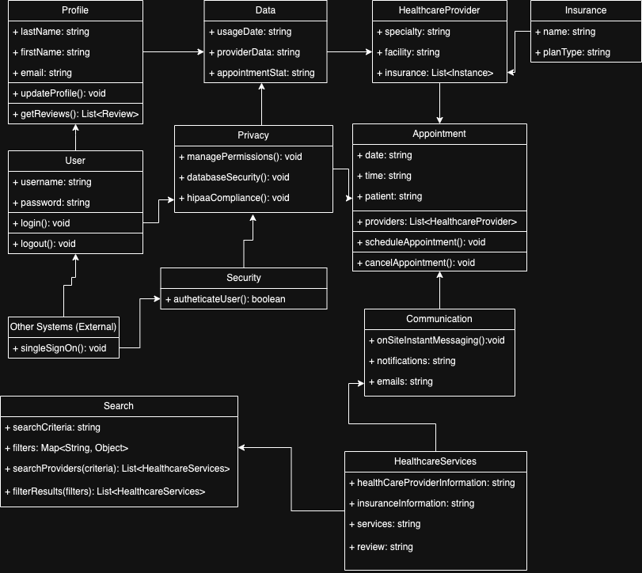

**3. UML Design Class Diagram:**

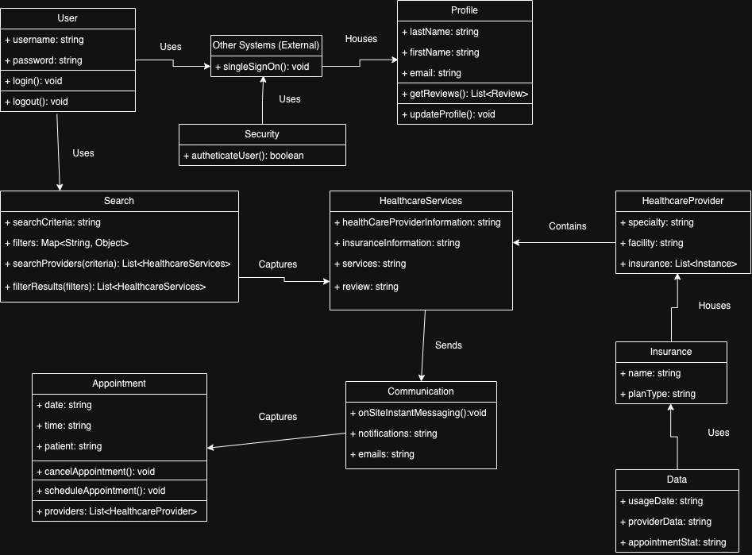

**4. UML System Sequence Diagram (SSD) for the above PD UC**

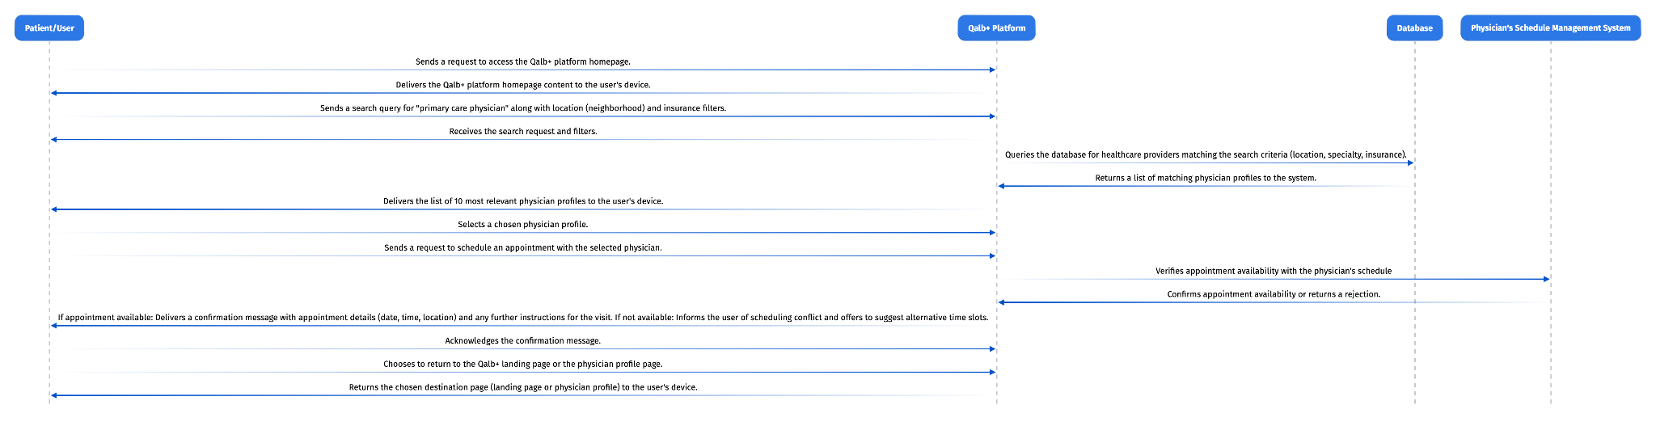

**5. UML System Operation Contracts (State Diagram)**  
  
Use Case Selected: Searching for a new primary care physician

| Field | Description |
| --- | --- |
| Name: | search(searchCriteria, filters, searchProviders) |
| Responsibilities: | Retrieves a list of results (primary care physicians) matching the user’s search criteria |
| Type: | System |
| Cross References: | Use Case Selected: Searching for a new primary care physician |
| Notes: | N/A |
| Exceptions: | Incoherent information was entered a search input; yielding no results |
| Output: | Top results of primary care physicians with healthCareProviderInfromation, insuranceInformation,services, and reviews listed. |
| Pre-conditions: | - Patient/User is live and authenticated on the platform with its own preferences and profile established.   - The relationships between the Healthcare Services, Communication, and Appointments in the database are established and known to the system |
| Post-conditions: | - Top results of primary care physicians are returned; best aligned with the search criteria - Relevant details like insurance information, location, and reviews are displayed. |

| Field | Description |
| --- | --- |
| Name: | appointment(date,time,patient | providers,scheduleAppointment,cancelAppointment) |
| Responsibilities: | Allows a user to schedule an appointment with the selected result from search input |
| Type: | System |
| Cross References: | Use Case Selected: Searching for a new primary care physician |
| Notes: | N/A |
| Exceptions: | All appointments for the selected primary care physician are booked. |
| Output: | Patient/User selects the most optimal result option and schedules an appointment with them through the platform portal. |
| Pre-conditions: | - Patient/User is live and authenticated on the platform with its own preferences and profile established.   - The relationships between the Healthcare Services, Communication, and Appointments in the database are established and known to the system |
| Post-conditions: | - The platform presents the 10 most relevant options based on the criteria given.  - Patient/User selects the most optimal option and schedules an appointment with them through the platform portal. |

| Field | Description |
| --- | --- |
| Name: | communication(notifications, emails, onSiteInstantMessaging) |
| Responsibilities: | Controls sending the appointment confirmation notification and email once it was successfully booked. |
| Type: | System |
| Cross Reference: | Use Case Selected: Searching for a new primary care physician. |
| Notes: | N/A |
| Exceptions: | User’s profile settings are configured to block notifications and third-party emails. |
| Output: | The platform provides the patient/user with a confirmation of appointment scheduled and further instructions of what is needed for the appointment. |
| Pre-conditions: | Ensure profile settings allow for notifications and third party emails |
| Post-conditions: | - The platform provides the patient/user with a confirmation of appointment scheduled and further instructions of what is needed for the appointment. |

**6. UML Interaction Diagrams (Activity Diagram)**  
  
**Operation Contract 1 :**  
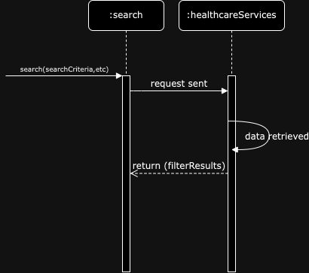

**Operation Contract 2 :**  
  
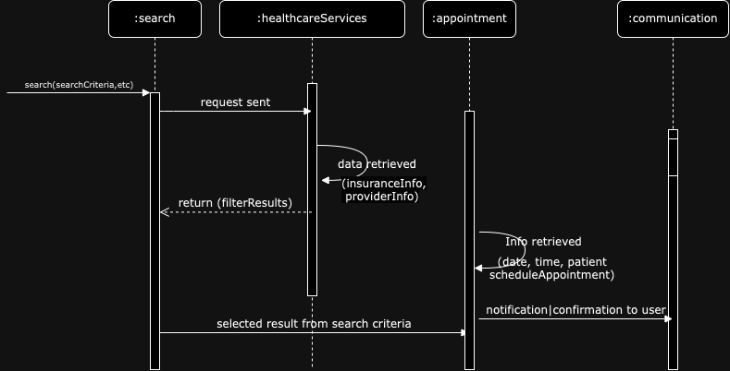

**Operation Contract 3 -**   
  
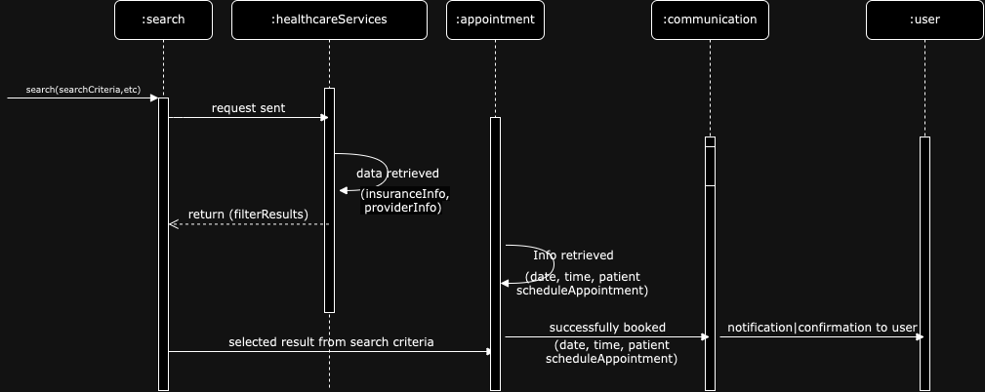

**7. UML Component Diagram:  
  
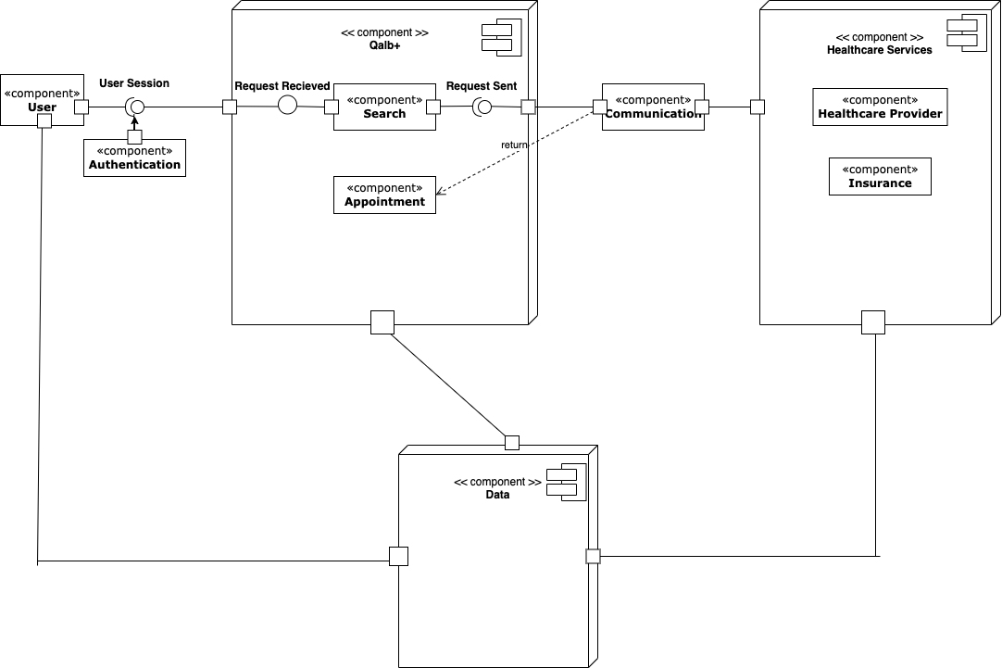**

**Rationale:**I went this route with my component diagram for one main reason; to clearly display how each component is responsible for one clear aim within the entire system and only interacts with other essential elements on a need-to-know basis. I ensured to include the two types of component interfaces where necessary, ports on the proper components, and the correct notations to represent the different types of relationships. A part of my design process was understanding what the core components were and the relationships that were between them. After reviewing my design class diagram, it was important to me to simply and clearly model the physical database, which I feel I was able to accomplish while properly displaying the full scope of the Qalb+ system.

**8. UML Cloud Deployment Diagram:**

**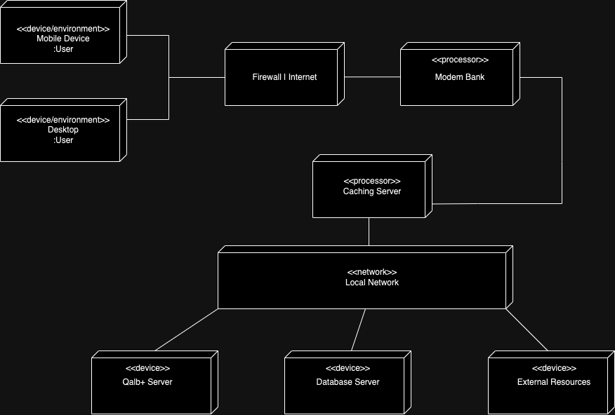  
  
Rationale:**I went this route with my deployment diagram for a few reasons; to show the structure of the run-time system and to also display what and who will interact within the system. I ensured to have nodes represented as 3-D boxes, connections between the nodes represented with a line and a <<stereotype>>, and keep it simple to navigate and follow. A part of my design process was understanding what the core components were and the relationships that were between them. After reviewing my design class diagram, it was clear to me that my <<device>> nodes should be the user devices, the Qalb+ server, database server, and external systems (single sign on, appointment gateway). While I weighed my options about whether it should be cloud or non cloud deployments, I opted for a non cloud design.

**9. Tech Stack and Cloud Service Provider:**- User Interface Layer:   
  
 Technology: HTML, React, CSS  
 HTML: helps define the structure of the Qalb+ core content  
 React: a modern and efficient way of making Qalb+ content interactive  
 CSS: determines the style and layout of the Qalb+ core content  
  
- Service Layer:   
  
 Technology: Gatsby.js w/ Node.js  
 Gatsby: Gatsby is an open-source static site generator built on top of Node.js using React and GraphQL. It can be used to build static sites that are progressive web apps, follow the latest web standards and optimized for speed and security.  
  
- Database Layer:   
  
 Technology: MongoDB  
 MongoDB: It’s a popular NoSQL database that’s well-suited for storing and managing data and developing scalable applications with evolving data schemas.   
  
- Cloud Deployment:  
  
 Technology: Amazon Web Services